# Lab Exercise 16– Terraform Variables with Command Line Arguments

**Name- Arin Agrawal**

**SAP ID- 500120660**

**Batch- 1**

**Objective:**

Learn how to pass values to Terraform variables using command line arguments.

# Steps:

1. **Create a Terraform Directory:**

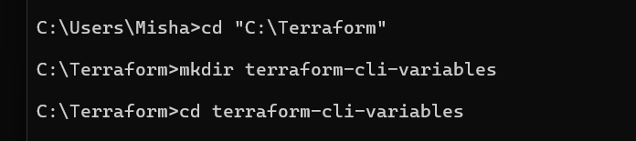

1. **Create Terraform Configuration Files:**
   * Create a file named main.tf:

# instance.tf





* + Create a file named variables.tf:

# variables.tf



# Use Command Line Arguments:

* + Open a terminal and navigate to your Terraform project directory.
  + Run the terraform init command:





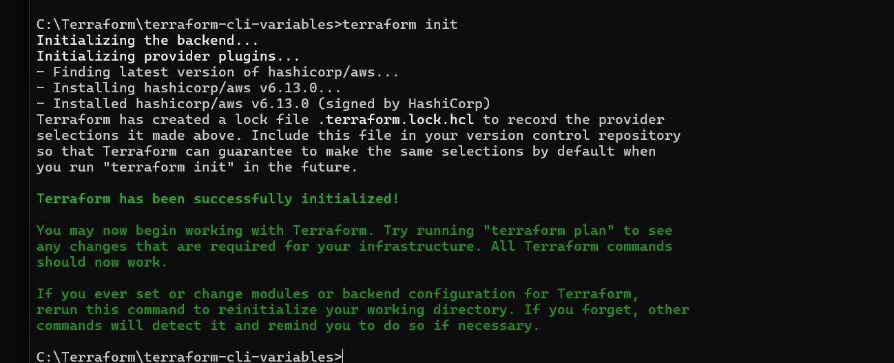

* + Run the terraform apply command with command line arguments to set variable values:



* + Adjust the values based on your preferences.

# Test and Verify:

* + Observe how the command line arguments dynamically set the variable values during the apply process.
  + Access the AWS Management Console or use the AWS CLI to verify the creation of resources in the specified region.

# Clean Up:

After testing, you can clean up resources:



Confirm the destruction by typing yes.